Crypto Price Prediction
Using Machine Learning and Deep Learning
ECPS 211: Machine Learning and Data Mining
Winter 2026
Group Members
Tae Moon
Ronnie Yin
Javier Ramos
Abhijit Rao
Hanish Kishan

1. Introduction
Cryptocurrency markets offer a unique and challenging environment for machine learning research. Trading 24 hours a day, seven days a week, these markets are characterized by extreme volatility, rapid regime shifts, and a notoriously low signal-to-noise ratio. With global market capitalization exceeding two trillion dollars, they have attracted significant interest from both practitioners and researchers looking to apply predictive models to price forecasting.
The task of predicting next-day price direction is harder than it might appear. Raw price series are non-stationary, which means models trained on price levels tend to overfit historical patterns and fail to generalize. More fundamentally, if price movements were easily predictable, arbitrage would quickly eliminate the signal, which is a consequence of the Efficient Market Hypothesis. Our approach sidesteps these issues by predicting next-day returns rather than raw prices, which are stationary and scale-invariant across assets and time periods.
A deeper problem with most published forecasting work is the evaluation gap. Various papers report mean absolute error (MAE) and root mean squared error (RMSE), but these metrics say nothing about whether a model can actually make money. A model can have low MAE while consistently predicting the wrong direction during trending markets. To close this gap, we implement a simple long-short backtest that converts directional predictions into cumulative profit-and-loss and Sharpe ratio, giving a clearer picture of real-world utility.
This project builds and evaluates a complete prediction pipeline on Ethereum (ETH-USD) as the primary asset, extended to three additional cryptocurrencies for generalization testing. We compare two naive baselines against Ridge regression with lag features and a two-layer LSTM, and conduct an ablation study, interpretability analysis, and residual error analysis to understand where and why the models succeed or fail.
The remainder of this report is organized as follows. Section 2 describes our methodology, including data preparation, feature engineering, and model design. Section 3 outlines the evaluation framework. Section 4 presents quantitative results with figures and discussion. Section 5 concludes with key takeaways and limitations.

2. Method

2.1 Dataset and Feature Engineering
Daily OHLCV price data for ETH-USD (Ethereum) were downloaded from Yahoo Finance using the yfinance library, covering the period from November 2017 through March 2026, yielding approximately 3,038 rows. After dropping an initial burn-in window used for lag construction, the working dataset contains 3,008 observations. Forward-fill is applied to handle any missing days, and the datetime index is kept time zone-naive for consistency.
Rather than working with raw close prices, we transform the data to next-day returns defined as rₜ = (Pₜ − Pₜ₋₁) / (Pₜ₋₁ + ε), where ε is a small constant added for numerical stability. This transformation makes the series approximately stationary and avoids the scale dependence that plagues models trained directly on prices. Three features are derived: the return series itself, a 14-day rolling standard deviation of returns (volatility_14), and the log-transformed trading volume (log_volume = log(1 + volume)). Crucially, volatility_14 is computed using only past returns at each timestep, with no forward leakage.
For Ridge regression, the feature matrix consists of the 30 most recent daily returns (lag_1 through lag_30, where lag_1 is yesterday), plus log_volume and volatility_14, for a total of 32 features per sample. For the LSTM, each training example is a sequence of 30 consecutive timesteps, each containing the three features (return, log_volume, volatility_14).

2.2 Train, Validation, and Test Split
All data splits are strictly chronological, with no shuffling performed at any stage. The dataset is divided 70/15/15 into training (2,105 rows, December 2017 to September 2023), validation (451 rows, September 2023 to December 2024), and test (452 rows, December 2024 to March 2026). All scalers are fit exclusively on training data and applied to validation and test sets, preventing any leakage of future information. The same test period is used for every model, ensuring fair comparison.

2.3 Baseline Models
We implement two baselines that require no learning. The first is the last-value baseline, which predicts tomorrow’s price to be equal to today’s (i.e., zero return). This is a surprisingly strong benchmark on magnitude metrics because daily price changes are small relative to absolute price levels. The second baseline is the 7-day moving average, which smooths over short-term noise and achieves meaningful directional accuracy by capturing local trends.

2.4 Ridge Regression
Ridge regression with an L2 penalty is our primary machine learning model. The full pipeline is: (1) standardize all 32 features using a ColumnTransformer fit on training data only (2) train a Ridge model on the standardized features to predict next-day return. The hyperparameter α (regularization strength) is tuned with Optuna, which uses Bayesian optimization (Tree Parzen Estimator) to search over α ∈ [0.01, 100] across 30 trials, using 5-fold time-series cross-validation on the training set with MAE on returns as the objective. The best α found was 99.27, indicating that heavy regularization is appropriate given the noisy return series. Predicted prices are recovered via P̂ₜ₊₁ = Pₜ × (1 + r̂ₜ₊₁).

2.5 LSTM
The LSTM model uses the same return-based target and the same strict leakage prevention. Input sequences of length 30 are scaled using a StandardScaler fit on training data and reshaped to (samples, 30, 3) before being fed to the network. The architecture consists of two LSTM layers with 64 and 32 units respectively, each followed by a dropout layer (rate 0.2), and a final Dense(1) output layer. The model is trained with MSE loss, the Adam optimizer, and a batch size of 32. Training uses early stopping (patience 15 on validation loss) and ReduceLROnPlateau with a factor of 0.5 (patience 5, minimum learning rate 10⁻⁶). Training stopped at epoch 47 with best weights restored from epoch 32.
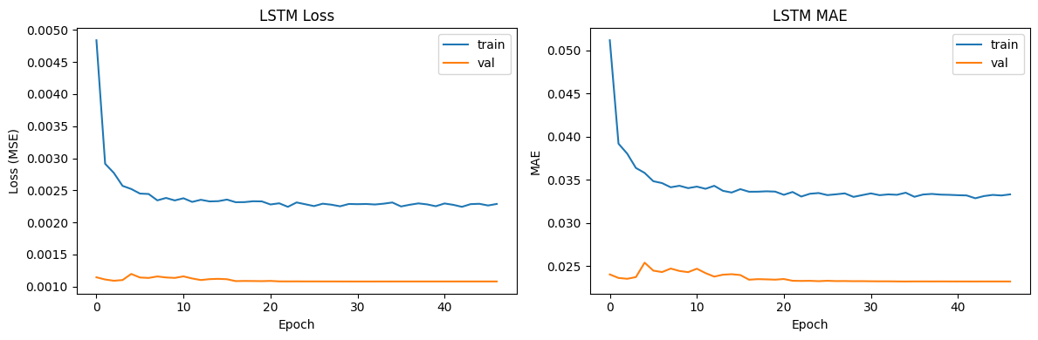
Figure 1. LSTM training and validation loss (MSE) and MAE over epochs. Early stopping restores weights from epoch 32.

3. Evaluation Setup

3.1 Metrics
We report three metrics for each model. Price-level MAE and RMSE measure magnitude error on the reconstructed price sequence, enabling direct comparison with the last-value baseline. Directional accuracy is the fraction of test days on which the model correctly predicts the sign of the next-day return. This metric is most relevant for trading applications. Because the last-value baseline always predicts zero change, its directional accuracy is undefined and reported as 0%.

3.2 Expanding-Window Walk-Forward Evaluation
A single train-test split can be misleading if the test period happens to be particularly easy or hard. To obtain a more stable estimate of generalization, we apply an expanding-window walk-forward evaluation to Ridge. The model is retrained on all available data up to the start of each of five sequential test windows, and directional accuracy and return-level MAE are recorded per window. The mean and standard deviation across windows provide a confidence-adjusted estimate of performance.

3.3 Long-Short Backtest
To assess practical trading value, we simulate a simple long-short strategy on the test set. On each day, the model predicts the next-day return. If the prediction is positive the strategy takes a long position (+1), and if negative it takes a short position (−1). There is no neutral position. Execution costs of 10 basis points are charged on each trade (position change). Cumulative P&L is the running sum of daily position × actual return minus costs, and the annualized Sharpe ratio is computed as the mean daily P&L divided by its standard deviation, scaled by √252. This setup is intentionally simple, it tests whether directional predictions carry economic value, not whether a production-ready strategy can be built.

4. Results

4.1 Baseline and Model Performance
Table 1 shows the performance of all four models on the ETH-USD test set (December 2024 to March 2026, 452 days). The last-value baseline achieves the lowest MAE ($82.21) and RMSE ($117.91) among all models, which is not surprising because daily returns are small, predicting zero change is a strong strategy on magnitude error. The 7-day moving average performs worse on price error but achieves meaningful directional accuracy of 51.6%.
Model | MAE (price) | RMSE (price) | Dir. Acc. | MAE (ret.)
Last Value | $82.21 ★ | $117.91 ★ | 0%* | N/A
7-Day MA | $138.74 | $192.77 | 51.6% | N/A
Ridge | $83.72 | $118.41 | 54.2% ★ | 0.0285
LSTM | $82.13 | $117.89 | 46.3% | 0.0280
Table 1. Full model comparison on the ETH-USD test set. ★ = best in column. *Last value predicts zero change so directional accuracy is not defined.
Ridge regression achieves the highest directional accuracy of all models at 54.2%, trading a slight increase in price MAE ($83.72 vs. $82.21) for a meaningful gain in directional signal. The LSTM, despite its greater model capacity, falls below 50% directional accuracy (46.3%) on this test period, suggesting it overfits or fails to capture the relevant signal on this particular asset and window. Both ML models are competitive with the last-value baseline on price MAE.
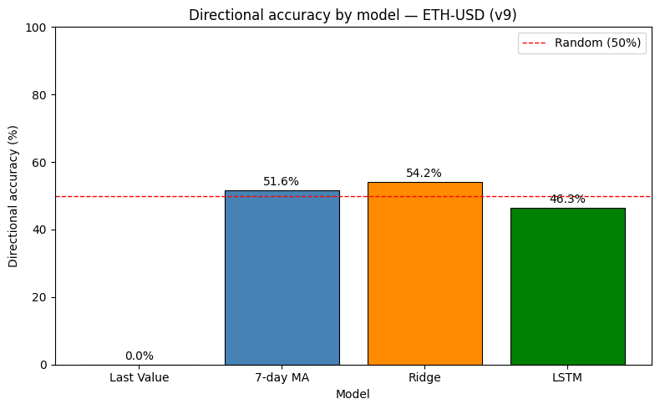
Figure 2. Directional accuracy by model on the ETH-USD test set. Ridge is the only model to consistently beat the 50% random baseline.

4.2 Long-Short Backtest
The most striking results come from the long-short backtest. Ridge generates a cumulative return of +120.6% over the test period (169 trades, Sharpe ratio 1.14), while the LSTM loses 159.3% (61 trades, Sharpe ratio −1.50). This is a remarkable divergence given that the two models have similar price-level MAEs. The key difference is directional accuracy, Ridge at 54.2% is consistently above the 50% threshold needed to profit with the long-short strategy, while the LSTM at 46.3% consistently trades on the wrong side of the market.
A Sharpe ratio of 1.14 for Ridge is a strong result, particularly given the simplicity of the model and the fact that ETH-USD experienced significant price swings and a broadly bearish trend over the test period (December 2024 to March 2026). This suggests that the Ridge model’s slight directional edge, sustained consistently across 169 trades, translates into meaningful economic value. The LSTM’s negative Sharpe of −1.50 demonstrates the danger of deploying a model with below-50% directional accuracy in a long-short framework.
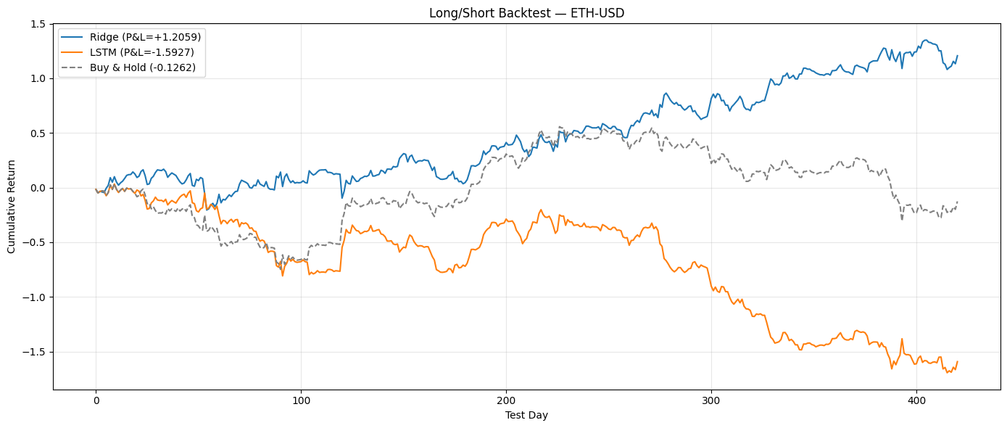
Figure 3. Cumulative P&L for Ridge (+120.6%, Sharpe 1.14) and LSTM (−159.3%, Sharpe −1.50) over the ETH-USD test set. Buy-and-hold shown for reference.

4.3 Expanding-Window Evaluation
The single-split test result could be lucky or unlucky. To assess whether Ridge’s directional accuracy is robust, we apply expanding-window walk-forward evaluation across five sequential test windows. Ridge achieves 55.55% ± 5.49% directional accuracy, confirming that the directional edge is not an artifact of a single favorable test period. The relatively low standard deviation (5.49 percentage points) suggests the model is reasonably consistent, though there is window-to-window variation that would matter in live deployment.

4.4 Ablation Study
To understand which features contribute to performance, Table 2 shows the results of training Ridge on four incremental feature subsets. Lags alone achieve the best return-level MAE (0.02819), while adding log_volume produces the largest gain in directional accuracy, jumping from 52.97% to 55.34%. Adding volatility alone provides little benefit over lags. The full 32-feature model lands between these extremes, confirming that volume is the most valuable auxiliary feature for direction prediction, while additional features introduce a small amount of noise on the magnitude metric.
Feature Set | # Features | MAE (return) | Dir. Acc.
Lags only | 30 | 0.02819 ★ | 52.97%
Lags + Volume | 31 | 0.02855 | 55.34% ★
Lags + Volatility | 31 | 0.02821 | 52.26%
All (full model) | 32 | 0.02850 | 54.16%
Table 2. Ablation study results on ETH-USD. Adding volume provides the largest directional accuracy gain. ★ = best in column.

4.5 Feature Importance and Interpretability
Permutation importance is computed on the Ridge model by shuffling each of the 32 features ten times and measuring the increase in MAE. Figure 4 shows that recent return lags (particularly lag_9, lag_16, and lag_30) are the most important predictors, with log_volume and volatility_14 also appearing in the top features. This is consistent with the ablation findings, that volume matters, but momentum lags form the backbone of the prediction.
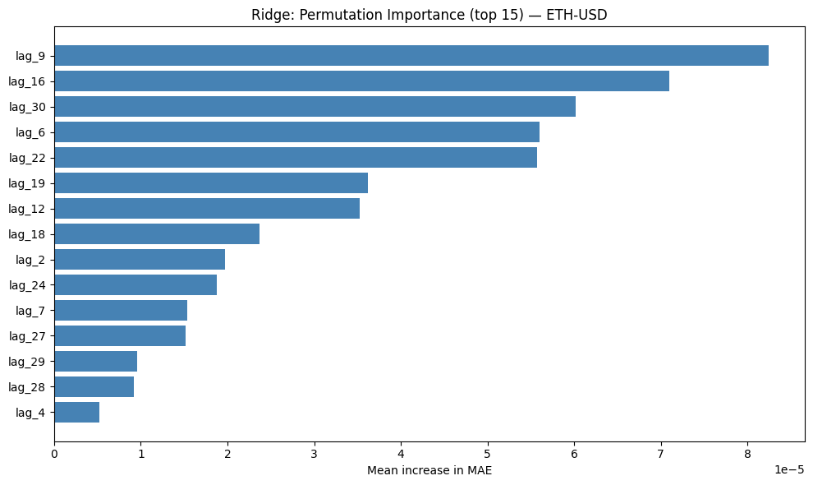
Figure 4. Permutation importance for the top 15 features of the Ridge model on the ETH-USD test set. Mid-range lags dominate.
Partial dependence plots (PDP) and individual conditional expectation (ICE) curves for the top two features show largely linear relationships, which is expected for a Ridge model. The PDP for lag_9 shows a positive slope, higher recent returns predict higher future returns, consistent with short-term momentum. The ICE curves are nearly parallel across samples, indicating that Ridge applies the same linear weighting consistently rather than relying on non-linear interactions.
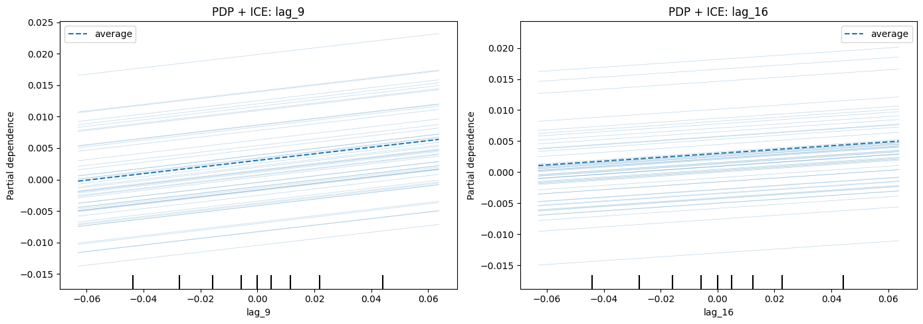
Figure 5. PDP + ICE for the top two features (Ridge). The linear response and parallel ICE curves confirm Ridge behaves as a smooth momentum extrapolator.

4.6 Error Analysis
Residual analysis on the Ridge test set reveals several systematic failure patterns, shown in Figure 6. The residual histogram is centered near zero but has heavy tails, meaning the model is occasionally very wrong in both directions. Temporal residual plots show that errors are not uniformly distributed. They cluster in distinct high-volatility regimes, particularly during sharp market moves. The scatter of |residual| against volatility_14 confirms a clear positive relationship, the model’s errors grow substantially during high-volatility periods.
This behavior is consistent with what we expect from a lag-based linear model. Ridge effectively extrapolates recent momentum. It
works reasonably well in calm trending markets but fails during sudden reversals or volatility spikes. This failure mode is a fundamental limitation of models that use only price and volume history, and is unlikely to be resolved without incorporating additional market or sentiment signals.
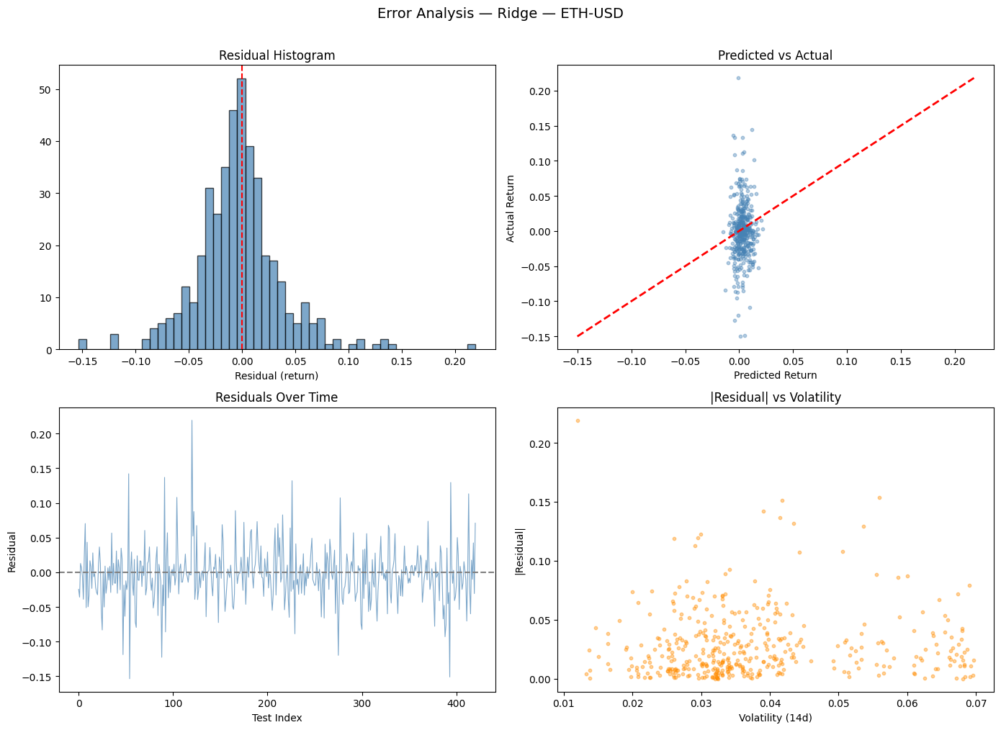
Figure 6. Residual analysis for Ridge on the ETH-USD test set. Large errors cluster in high-volatility periods (bottom right), confirming the model fails most during turbulent regimes.

4.7 Cross-Asset Generalization
Table 3 summarizes directional accuracy across four assets. The pattern is consistent, the last-value baseline is trivially zero, Ridge outperforms on ETH-USD, and both ML models struggle on XRP-USD. ETC-USD shows the highest directional accuracy for the 7-day MA (55.4%), while LSTM falls below 50% on every asset except BTC-USD. These results indicate that short-term directional predictability is asset-specific and generally modest. The pipeline is portable, running identically on any asset by changing the ASSET configuration variable, but the best model varies by market.
Asset | Last Value | 7-Day MA | Ridge | LSTM
BTC-USD | 0% | ~50% | ~49.6% | ~51.0%
ETH-USD | 0% | 51.6% | 54.2% ★ | 46.3%
XRP-USD | 0% | ~52.3% | ~50% | ~46.6%
ETC-USD | 0% | 55.4% ★ | 53.2% | 45.0%
Table 3. Directional accuracy across four assets. ★ = best directional result per asset.

5. Conclusion
This project developed and evaluated a return-based cryptocurrency price prediction pipeline with a focus on practical trading utility. The key finding is that Ridge regression with 30 return lags, log-volume, and 14-day rolling volatility achieves consistent directional accuracy of 54 to 56% on ETH-USD, which translates into a cumulative return of +120.6% and a Sharpe ratio of 1.14 under a simple long-short backtest. This stands in contrast to the LSTM, which achieves similar price-level MAE but falls below 50% directional accuracy and loses 159% in the same backtest, a reminder that magnitude error and trading value are not the same thing.
Several limitations are worth noting. The models are trained and tested on a specific period, and results may not generalize to future market regimes. The backtest makes strong simplifying assumptions (no slippage, immediate fill, symmetric long-short), which would not hold in practice for a highly volatile asset like ETH. The feature set is deliberately minimal and does not incorporate on-chain data, order-book information, or macroeconomic signals that could improve predictions. Finally, the LSTM results suggest that deep learning, at least in this simple form, does not provide a reliable advantage over linear models for this task on daily data.
Future directions include testing more sophisticated feature engineering (e.g., RSI, MACD), extending the backtest to a true rolling-window framework to better simulate concept drift, and evaluating ensemble approaches that combine the directional confidence of Ridge with the pattern-matching capacity of the LSTM. Adding position sizing based on predicted confidence or volatility could also significantly improve the risk-adjusted performance of the backtest strategy.

Appendix: Dependencies
The following Python packages are required to run all experiments:
Package | Version | Purpose
pandas | ≥1.5.0 | Data manipulation
numpy | ≥1.21.0 | Numerical computation
yfinance | ≥0.2.0 | Data download (Yahoo Finance)
scikit-learn | ≥1.2.0 | Ridge, pipelines, metrics, CV
tensorflow | ≥2.12.0 | LSTM model
matplotlib | ≥3.6.0 | Plotting
seaborn | ≥0.12.0 | Statistical plots
optuna | latest | Bayesian hyperparameter search

Team Contributions
Tae Moon
Coordinated the overall implementation and worked through multiple iterations to get the full modeling pipeline running end-to-end. Contributed to the LSTM architecture, error analysis, and key findings, and had a hand in every part of the project throughout development. The team worked together to run tests, catch errors, and brainstorm solutions at each stage.
Ronnie Yin
Worked on baseline models, Ridge regression, and feature ablation sections of the report. Helped with final document formatting and cross-referencing all data points to ensure accuracy before submission. Participated in testing iterations, helped identify errors, and contributed to group brainstorming throughout development.
Javier Ramos
Contributed to the full model comparison, generalization across cryptocurrencies, and permutation importance sections of the report. Assisted with testing iterations and helped identify issues during development.
Abhijit Rao
Contributed to the expanding-window evaluation, rolling backtest, and cumulative return sections of the report. Assisted with testing iterations and helped catch bugs during development.
Hanish Kishan
Contributed to the project overview, dataset and features, and evaluation framework sections of the report. Assisted with testing iterations and helped identify errors during development.

